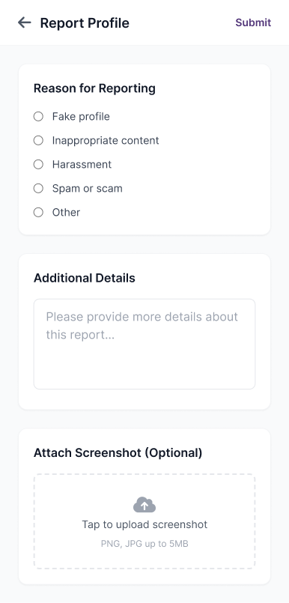

Reason for Report
◉ Fake Profile
◉ Inappropriate Content
◉ Harassment or Abuse
◉ Spam or Scam
◉ Other

Additional Details
Share a brief description of the issue…

Attach Screenshot (Optional)
Add a photo to support your report.

